Intermediate

#### Species

* Coffea Arabica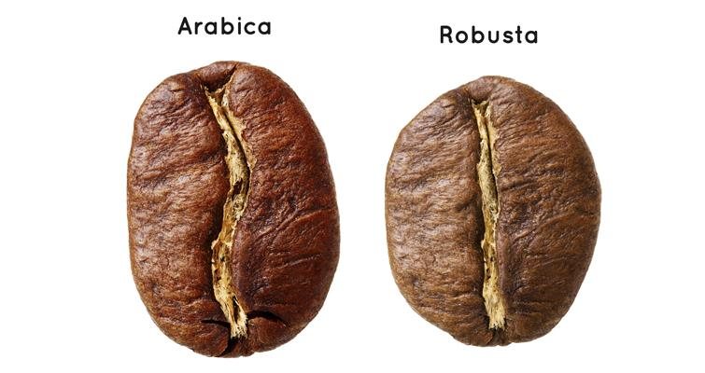
  + More desirable cup profile
  + Higher _______
  + Less bitterness
  + Complex, more sweetness
* Coffea Canephora (Robusta)
  + More bitterness
  + Higher ________ content
  + _______ body
  + More pest/disease ___________
  + Handles harsher growing conditions

#### Varieties

*Subtypes of species*

* Breeds of coffee have different characteristics

Important Varieties

* + Typica
  + Bourbon

Other common varieties:

* Resource: World Coffee Research catalog

#### Origins

* “Coffee Belt” - near/around the ____________
* Central + South America (Brazil, Costa Rica, etc.)
  + Round, Nutty, Chocolates
* East Africa (Ethiopia, Kenya, etc.)
  + High acidity, __________, Fruity
* Southeast Asia (Indonesia, Papua New Guinea, etc.)
  + Herbal, Savory, ___________, Tropical

#### Processing

* Washed / Wet / Parchment Dried
  + Higher __________
* Natural / Dry / Fruit Dried
  + Fuller __________
* Honey / Semi-washed / Pulped Natural / Pulp Dried
* Experimental
  + Lactic, Haraaz Special Prep, etc.

#### Roast Date

* Crema
  + Older coffee will tend to be thinner
* Flow rate
  + Extraction process/rate speeds up
* Grind Setting
  + _______ coffee will need a finer grind to achieve similar flow rate
* Releasing CO2
  + Coffee releases Carbon Dioxide as it ages

##### 

##### Workflow and Layout

Equipment should be organized and positioned to maximize efficiency and promote speed of service.

* Position of grinder + knock box
  + Ideally on the side of the espresso machine towards ordering area
* Fridge
  + Ideally underneath espresso machine
* Cups + syrups
  + Closest to ordering area
* Other tools

##### Double Baring

Cooperation of baristas to achieve higher efficiency and speed of service.

*E.g. One person pulls shots, the other steams and pours milk*

Dose Output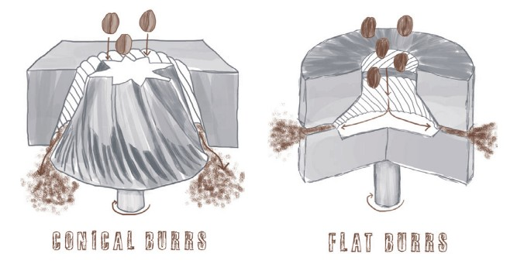

* Grind size adjustment may require change in grinding time
* Finer - burrs get closer
* Coarser - burrs farther apart

##### Heat

* Burrs get hot during peak hours
* How does this affect extraction?
  + Decreases overall ________
  + Necessitates change in grind size

##### Burr Quality

* Dull Burr Symptoms
  + Feel “polished”
  + Grinder overheats
  + Difficult to calibrate
  + Drink quality diminishes

##### Consistency

* Controlling your variables
  + Maintaining consistent variable to achieve consistent extraction

##### Channeling

* Uneven flow of water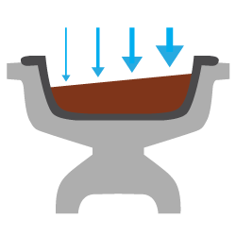
* Even distribution is key

##### Balance

* Acidity
* Sweetness
* Bitterness

##### Extraction

* Acids
* Sugars, Carbohydrates
* Alkaloids / Tannins

##### Correcting Imbalance

Yield (output weight)

* Brew ratio 1:1.5 to 1:2.5

Grind size

* Finer: More extraction for given dose/yield
* Coarser: Less extraction for given dose/yield

Dose weight

* Affects concentration and brew ratio

##### Brew Ratio and Espresso Brew Formula (EBF)

Describes relationship of coffee and water.

EBF = (espresso dose weight ÷ espresso beverage weight) × 100

Brew Ratio example: 1:1.5 → 18 gram dose: 27 gram bev. Yield

EBF Calculation:

Find your beverage weight for a 18.5g dose weight and a 55% Brew Ratio



##### Refractometer

* Tool for reading TDS
* Software - VST Coffee Tools
* Based on how much light can pass through the liquid

Extraction yield % = Beverage Weight[g] x TDS[%] / Dose[g]

E.g.

*EY = 38g x 9% / 17g*

*EY = 20.1%*

#### SCA Flavor Wheel

* Developed by a sensory panel of professionals from various companies
* Gives an international base for communication
* Helps teams get calibrated

#### Milk Composition

* Fat (Lipids)
  + Ability of microfoam to re-incorporate, remain liquidy
* Protein
  + Affects stability of microfoam

Balance of these components to create dense microfoam with texture of “wet paint”

#### Milk Alternatives

* Soy, almond, oat, coconut...

#### Milk Expiration

* Lumpy or watery
* Coagulated on top
* Bubbles fizzing

Suggests that milk may be spoiled.

Spoiled milk will be unable to maintain good texture.

#### Temperature

Recommended drink temp is _________°F

Maximum of 158°F

#### Foam Level

One third increase in volume from cold milk to steamed milk.

#### Latte Art

* Dot / Monk’s head
* Heart
* Tulip
* Rosetta

#### Milk Sharing

Preparing milk for more than one beverage while maintaining foam quality standards.

Useful for increasing efficiency of workflow

#### Menu Recipes

* Macchiato
* Cortado
* Cappuccino
* Latte

#### Order of Preparation

Beverages are prepared in order of size from largest to smallest.

#### **Practical**

* Pulling shots and steaming milk simultaneously
* Prepare 4 beverages in 5 minutes

#### Hygiene & Safety

* Using clean towels
* Handwashing frequently
* Using clean milk pitchers

#### Contamination Risks

* Cross
  + Using counter towel for steam wand
  + Using drip tray towel to wipe portafilter
* Direct
  + Milk left out, incorrect storage temperatures
  + Storage containers left open
  + Pest control
  + Sneezing or coughing

#### Workplace Injury

* Burns
* Broken glass
* Dropping tamp
* Strained wrist from incorrect technique
* Spills and slipping
* Cleaning grinder burrs
* Electrical cords
* Chemicals stored near food

**Abide by all local and federal regulations for food and worker safety. Strive to follow food handling certifications and teachings.**

#### Customer Recovery

* Listen
* Be sincere
* Don’t try to deny, explain, or make excuses
* Ask what will make things right

#### Personal Presentation

* Clean clothing, hair, and fingernails
* Neat apron
* Open body language and posture
* Easy going demeanor

#### Communication

* Ask questions
* Give suggestions
* Maintain communication during preparation
* Confirm handoff

#### Efficiency

* Remember regulars
* Manage lines, take orders quickly
* Workflow to save time and energy
* Maintain a clean and stocked station

#### Boilers

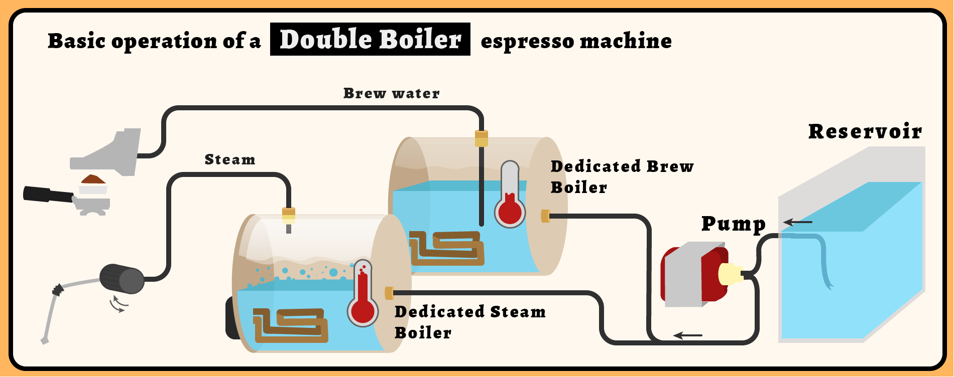

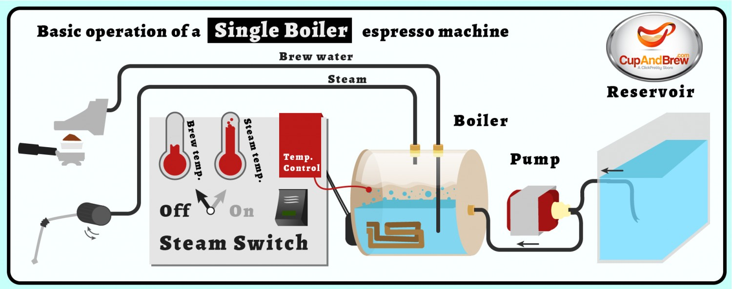

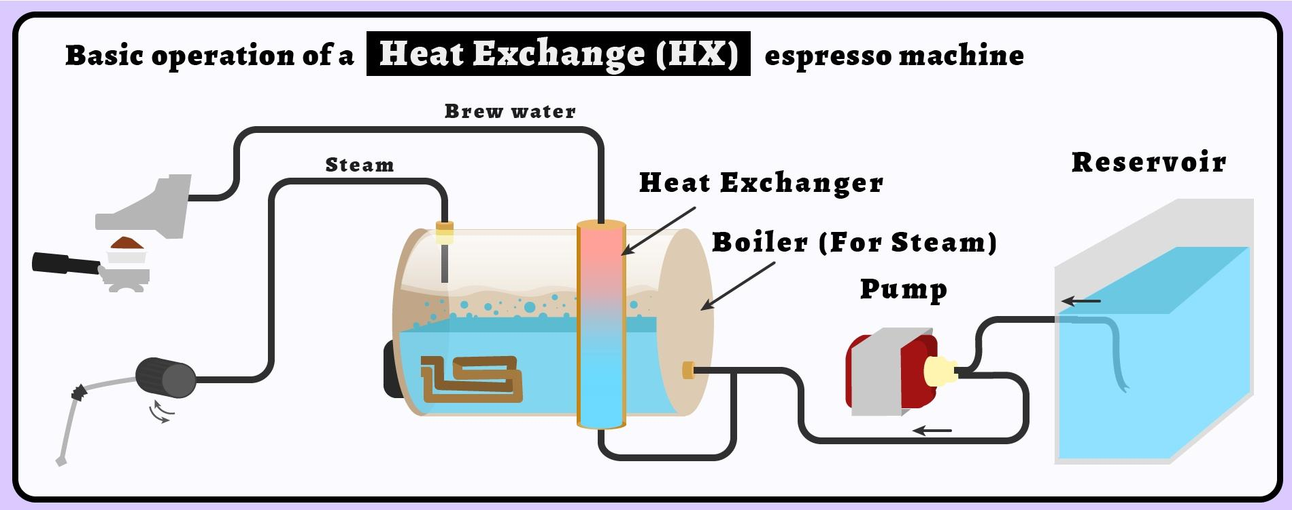

#### Preventative Maintenance

* Backflushing daily
* Using correct detergents + solutions
* Replacing gaskets
* Checking water filtration

Poor maintenance can cause equipment malfunction and breakage.

*E.g. How could a buildup of coffee oils / particles on a grouphead filter screen affect extraction?*

* *Blockages causing uneven flow of water*
* *Blockages may cause high pressure jets, wetting coffee unevenly*
* *Overall pressure may be decreased*
* *Oils may impart “dirty” or musty flavors*

#### 

#### 

#### Cafe Management

* Calculating costs to achieve profit
* Ingredient Storage
* Strategies to minimize waste
* Human resources

**Calculating gross profit**

G. Profit = Sale price - Tax - Cost of Goods

*E.g. $4.00 item with a 15% tax and a cost to make of $1.05*

*G.Profit = 4 - (4*.15) - 1.05 = $2.35*

*Gross profit percentage = $2.35 / $4.00 = 58.7%*